## **Research Proposal**

*Constraints on Chinese Invasive War on Taiwan, and Public Opinion in Cross-Strait Relations*

### **Research Questions**

1. What are the primary deterrence mechanisms preventing China from launching a full-scale war on Taiwan, how does governance challenge function as an additional deterrent?
2. How has Taiwanese public opinion on independence and national identity evolved over time, what would be the most significant factors shaping these views, and how do different factors interact to influence public sentiment toward the future of cross-strait relations?

### **Introduction and Roadmap**

The unresolved Taiwan Strait conflict, rooted in colonial legacies, historical grievances, and political complexities, remains one of the most volatile flashpoints in international politics. Despite the Chinese Communist Party (CCP) placing Taiwan’s reunification at the forefront of its national agenda, Beijing has refrained from launching a direct military invasion or attempting full-scale annexation. This enduring restraint, even as China’s military and economic power expands, raises a critical question: What are the primary deterrence mechanisms preventing China from launching a full-scale war on Taiwan, how does governance challenge function as an additional deterrent? I will explore the contributions and limitations of current military-deterrence and economic interdependence-based deterrence mechanisms, and detail how governance challenge functions as a product of military-deterrence and economic interdependence that completes the puzzle previous studies have failed to address.

This study will also investigate the development of Taiwanese public opinion and national identity. I adopt Niou’s (2004) “conditional preference” framework[1] to analyze how different factors interact to shape Taiwanese attitudes toward independence, the status quo, and unification under different controlling conditions. By integrating these dimensions, this research aims to provide a more comprehensive explanation of both China’s restraint and Taiwan’s internal dynamics in shaping the future of cross-strait relations.

### **Significance**

Why should we care about this? Answering this question has profound implications for the study of regional stability in East Asia, global security frameworks, and the future of U.S.-China relations. As tensions in the Taiwan Strait intensify, understanding the mechanisms that prevent war is critical for policymakers, scholars, and international actors seeking to maintain peace and stability in the Indo-Pacific. Much of the existing scholarship focuses on military deterrence (e.g., U.S. intervention, Taiwan’s defense strategies) and economic interdependence as the primary reasons why China has not invaded. However, this study introduces governance-legitimacy challenges as an overlooked but critical deterrent. If war risks domestic instability and legitimacy crises within the CCP, these factors may be just as powerful in restraining Beijing as military threats or economic sanctions.

Taiwanese public opinion also plays a critical role in cross-strait relations, yet it is often treated as a secondary factor in discussions of deterrence. This study bridges the gap between deterrence theory and public opinion research by examining how evolving Taiwanese identity, economic interests, and security concerns create conditional preferences that influence Taiwan’s political trajectory. Understanding these dynamics is essential because public sentiment directly affects Taiwan’s policy decisions, elections, and diplomatic positioning, which in turn shape Beijing’s strategic considerations.

### **Literature Review on Cross-Strait Deterrence Mechanisms**

Scholars have attempted to answer this first research question in two main directions. First, there are **strict, material-based military deterrence mechanisms** that raise the cost of invasion beyond an acceptable threshold for Beijing. Rationalist theory of war argues that leaders weigh the credible commitment problems and uncertainties in any conflict[2]. China’s leadership may doubt its ability to swiftly conquer Taiwan. Taiwan’s geographic advantages, including its mountainous terrain, shallow waters, and heavily fortified coastline, make amphibious landings extremely difficult, limiting the effectiveness of a rapid conquest[3]. Moreover, Taiwan has invested significantly in asymmetric defense strategies, such as mobile missile launchers, sea mines, and anti-ship missiles, which could effectively counter a large-scale amphibious assault by the People’s Liberation Army (PLA)[4]. U.S. military presence and commitment is also existent. The long-standing policy of strategic ambiguity leaves the possibility of direct U.S. intervention open, forcing China to consider the risk of a broader regional conflict[5]. The presence of U.S. forces in Japan, South Korea, and Guam, along with arms sales to Taiwan, enhances Taipei’s ability to resist aggression. U.S. military doctrine also includes strategies aimed at “system overload”, where China’s ability to fight a war in Taiwan would be compromised by simultaneous pressures on other fronts, including potential U.S. or allied actions in the South China Sea or Indian Ocean[6]. Allied participation is supported by both signed mutual defense treaties and the existence of regional norms. Simmons (2000) finds that regional norms encourage a state’s compliance when neighboring states have already done so[7]. Additionally, nuclear deterrence remains an overarching constraint. Although China maintains a “no first use” nuclear policy, it faces the reality that a prolonged conflict in Taiwan could escalate in unpredictable ways, increasing the risks to China’s broader national security interests[8].

However, with the rapid expansion of the PLA’s military capacities—evidenced by the deployment of additional aircraft carriers, amphibious assault ships, sixth-generation fighter jets, and advanced tactical missiles—the power gap between China and the U.S. is narrowing[9]. This shift, as suggested by classic Power Transition Theory[10], increases the likelihood of conflict, as rising powers seek to challenge the declining hegemon when they perceive a closing military advantage. Empirical findings by Kim and Gates (2015)[11] support this perspective, particularly in the context of China’s rise, **suggesting that military deterrence alone is insufficient to fully explain why Beijing has refrained from invading Taiwan to force reunification**.

Second, **economic interdependence** acts as another deterrent in cross-strait warfare. Classical liberal research suggests free trade reduces the likelihood of war[12]. Recent research on international trade and political relations[13] have also suggested that countries with high levels of economic interdependence posit stronger avoidance of conflict, as disruptions to trade directly impact domestic growth and employment. International trade is pivotal to China’s production and trade for its export-oriented economy and growth-based model[14], as the country needs to obtain key production materials from, as well as selling its product to the international market.

Economic sanctions historically have had a significant impact on countries engaged in military conflicts. For example, the sanctions imposed on Russia following its annexation of Crimea and its war on Ukraine led to measurable declines in trade and GDP, particularly due to reduced access to global financial markets and technology[15]. Similarly, sweeping sanctions imposed after the 2022 invasion of Ukraine disrupted Russia’s economy by limiting its ability to trade with Western nations, resulting in long-term economic consequences despite initial resilience[16].

China’s economy, deeply integrated into global trade networks, would likely suffer similar repercussions if it launched a military invasion of Taiwan. The U.S.-China trade war demonstrated how restrictions on exports and tariffs could lead to economic slowdowns, reduced market access, and disrupted supply chains[17]. Given that China depends on foreign technology transfers, semiconductor imports, and consumer markets in North America, Europe, and Asia, an invasion would trigger economic isolation and hurt the operation and development of its key industries.

Several studies have explored the role of economic interdependence in deterring conflict across the Taiwan Strait. Drezner, Farrell, and Newman (2021) argue that extensive trade and investment ties between China and Taiwan elevate the opportunity cost of war, making military escalation less rational for both sides[18]. Similarly, Kastner (2006) finds that cross-strait economic integration reduces the likelihood of conflict by fostering mutual dependencies[19]. However, recent trends toward economic and political decoupling[20]—accelerated by Pelosi’s 2022 visit—combined with Beijing’s growing willingness to prioritize political objectives over economic stability[21], **have weakened the effectiveness of this deterrent.**

### **My Addition to the Study of Cross-Strait Deterrence Mechanisms**

Despite the strengths of both military deterrence and economic interdependence in explaining China’s restraint, **previous studies have underexplored how governance and legitimacy challenges —both in post-war Taiwan and within mainland China—serve as additional deterrents to war in the Taiwan Strait.** The complexities of governing a post-invasion Taiwan, along with the potential for domestic instability within China, add significant political and administrative costs that harm the image and political legitimacy of the CCP, which ultimately disincentivize military action.

What constitutes governance challenges? They stem from several key factors that complicate effective rule and long-term stability for the CCP in both Taiwan and mainland following an invasive war.

First, governing a wartime regime differs significantly from peacetime governance. Civilian production would be subordinated to military needs, and everyday activities—such as shopping, entertainment, and travel—would become severely restricted, leading to civic dissatisfaction with the government. Wartime production and rationing would drastically limit access to goods and services, conditions that have historically led to social unrest and noncompliance, as seen during World War II[22].

Second, a war in the Taiwan Strait would likely cause widespread destruction to production facilities, infrastructure, and livelihoods, particularly in China’s economically vital coastal provinces. The government would not only need to address the immediate needs of displaced populations but also manage the complex task of allocating limited resources for relief, reconstruction, and economic recovery—challenges that could strain state capacity and legitimacy. Given that legitimacy is a crucial pillar of the CCP rule, the potential erosion of public confidence in the government’s ability to maintain stability and economic prosperity, from any civil casualties or failed attempts to counter-attack, could pose a significant threat to its survival—an issue I will further explore in the following paragraph.

Third, norms-based approaches offer new perspectives on how norm transgression creates governance challenges for the CCP by affecting domestic legitimacy. An invasive war on Taiwan contradicts international norms and will attract international criticism. While international criticism alone is unlikely to coerce a change in Chinese policy[23], shaming from adversaries can contribute to domestic discontent when citizens perceive their government as failing to uphold international expectations, as illustrated by the Boomerang Model from Keck and Sikkink[24]. Ian Hurd (1999)[25] argues that states follow international norms not just due to coercion or self-interest but also because they seek legitimacy in the eyes of both domestic and international audiences. When a state violates widely accepted norms, it risks undermining this legitimacy. Norm transgression fuels citizen dissent and harms China’s domestic and international political legitimacy.

Third, even if the Chinese government can maintain internal control on the mainland, ruling a former democracy of 24 million people—many of whom strongly identify as Taiwanese—under an authoritarian system would present significant difficulties, both materially and ideologically. *Materially*, Tseng (2018)[26] illustrates how the Kuomintang (KMT) wartime regime struggled with economic recession, resource shortages, and famine in the immediate postwar period—challenges that the CCP could similarly face under international sanctions and economic isolation following an invasion. *Ideologically*, the clash between Taiwan’s history of democratic-governance and Beijing’s centralized, high-pressure autocracy would likely generate intense political resistance. Furthermore, the conflict between Taiwanese identity and Beijing’s vision of a unified Chinese identity would foster deep distrust of CCP rule and intensify demands for political representation, as seen during both the KMT’s early rule of Taiwan[27] and the political turmoil in Hong Kong[28].

In summary, these governance challenges, coupled with strong national identity divisions, would make long-term rule over Taiwan, as well as the rule of the war-torn mainland, exceptionally complex and costly. However, to fully understand why governance challenges serve as a true deterrent to the CCP, it is crucial to examine what sustains the survival of the Chinese regime–**legitimacy and economic performance**.

Gerschewski (2013) identifies legitimacy, repression, and co-option as the three fundamental pillars that ensure the endurance of autocratic regimes, including China[29]. He argues that Beijing successfully restored public legitimacy after the 1989 Tiananmen protests by leveraging a combination of economic performance, nationalism, and ideological control. Similarly, Tang (2016) emphasizes the role of legitimacy in the CCP’s regime survival, noting that the party remains highly responsive to the needs and interests of the majority—primarily in the form of tangible economic growth—since it lacks the legitimacy derived from direct elections[30]. Zweig (2002) further supports this view, asserting that the CCP’s political survival is closely tied to economic growth[31]. In this framework, successful governance—characterized by sustained economic growth and responsiveness to public interests—remains central to the CCP’s legitimacy and long-term rule.

During wartime, any military failures, economic downturns, or actions that diminish public well-being could be perceived as governance failures, directly undermining the CCP’s political legitimacy and perceived performance—an existential threat to the regime. Given the near certainty of economic decline in the event of war, these governance challenges become a critical constraint on Beijing’s strategic calculus. Thus, I argue that governance challenges, in conjunction with military deterrence and economic interdependence, generate legitimacy concerns for the CCP. As both a byproduct and an extension of these deterrence mechanisms, **governance-legitimacy** challenges help explain why Beijing has thus far refrained from launching a full-scale invasion of Taiwan.

### **Literature Review on Taiwanese Public Opinion**

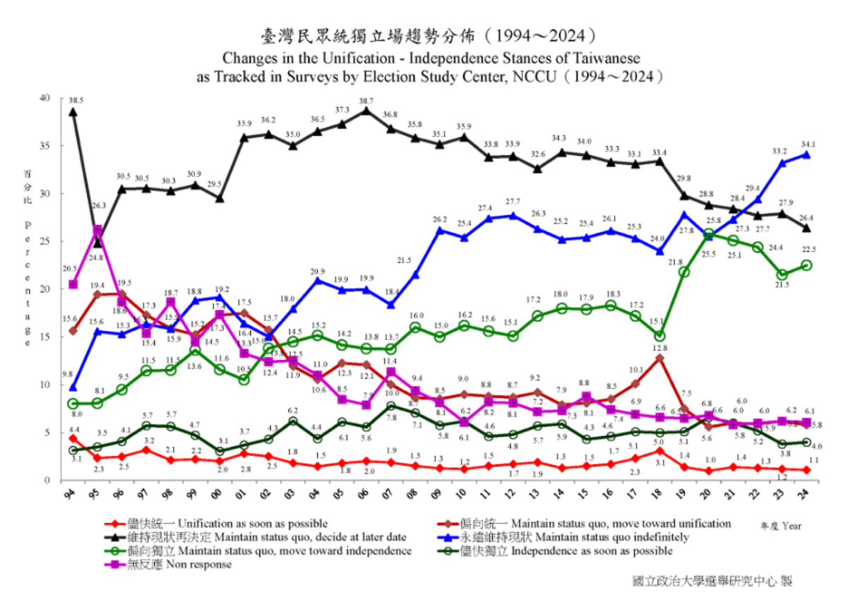The second research question of this proposal seeks to explore how Taiwanese public opinion on independence has evolved over time, identify the most significant factors shaping these views, and examine how these factors interact to influence public sentiment. The National Chengchi University (NCCU) data on unification-independence stances of Taiwanese has shown a growing majority of Taiwanese preferring either permanent status-quo or declaring independence, with only 16% inclined to endorse unification.

Figure 1. Unification - Independence Stances of Taiwanese, 1994-2024 (NCCU, 2025[32])

Several studies have examined the factors shaping Taiwanese public opinion on independence, the status quo, and unification; they have identified national identity, party identification, economic considerations, and military threat as key determinants. Chu's (2004) analysis of longitudinal survey data reveals that while efforts by Taiwanese leaders to promote a pro-independence sentiment have had some effect, the perception of China's *growing economic potential* and the *increasing inevitability of cross-strait economic integration* have somewhat constrained the popular support for Taiwan independence, particularly among the younger generation[33]. Sobel et al. (2010)[34] also note that cross-strait tensions and specific events like China's missile tests and leaders' speeches have influenced the Taiwanese public to become more independence-minded. Furthermore, Wang et al. (2025)[35] highlights that while Taiwanese nationalism has risen significantly, the majority still prefer the status quo due to a combination of concerns about China's potential military response to independence and the economic reliance on China. Lastly, Wang (2017)[36] also identifies the feeling of hostility from Beijing, particularly regarding diplomatic isolation, has also been a significant factor in hardening Taiwanese identity and a preference for a separate status.

While existing studies provide valuable insights into the determinants of Taiwanese public opinion on cross-strait relations, they often examine these factors in isolation, leaving their interactions and collective influence underexplored. Niou (2004) argues that for many in Taiwan, the preference between unification and independence is largely **conditional** on the perceived costs of each outcome, such as the likelihood of military conflict with China[37]. Wang et al. (2025) further this idea by testing Taiwanese preferences for independence and reunification under two specific conditions: whether China would declare war following a declaration of independence and whether Taiwan and China are politically, economically, and socially compatible. Nevertheless, while Wang et al.’s study is innovative, it remains limited in scope in two ways. First, it only tests two conditions, whereas Taiwanese preferences are likely influenced by a much broader set of variables, which I will detail in my research methodology section. Second, their approach is primarily descriptive, lacking more advanced statistical methods to systematically analyze how multiple factors interact to shape public opinion.

### **My Addition to the Study of Taiwanese Public Opinion of Cross-Strait Relations**

By addressing these limitations, my study aims to take one step further using Niou’s “conditional preference” framework to provide a more comprehensive understanding of the determinants of Taiwanese public attitudes. Rather than viewing support for independence or unification as absolute, Niou (2004) argues that Taiwanese preferences change in response to specific circumstances, such as China’s military threat, U.S. security commitments, and Taiwan’s economic prospects. This perspective challenges the notion that public opinion is static and highlights how strategic calculations influence decision-making even on grassroot level. I argue that a perceived high military threat, combined with low expectations of economic benefits from cross-strait interactions, shapes an individual’s preference for Taiwanese independence. No single factor alone is sufficient to fully explain public attitudes; rather, it is the interaction between security concerns and economic expectations that determines support for independence.

### **Theoretical Framework**

To summarize the literature review above, this study first examines the deterrence mechanisms preventing China from initiating a full-scale military invasion of Taiwan by developing a robust theoretical framework that synthesizes military deterrence theory, economic interdependence, and governance challenges.

Military deterrence, as articulated by Fearon (1994) and Mearsheimer (2001), argues that credible military threats significantly increase the potential costs of conflict, thereby deterring aggression. Taiwan’s military strategies, including asymmetric warfare capabilities, geographic defensive advantages, and the plausible threat of U.S. and ally military intervention, collectively elevate the strategic costs for China.

Economic interdependence theories (Kastner 2006; Drezner et al. 2021) further suggest that deep trade relationships and mutual economic vulnerabilities significantly deter conflict. China’s extensive economic integration into the global market, reliance on foreign technologies, and vulnerability to sanctions position economic disruption as a substantial deterrent, particularly given the CCP’s reliance on sustained economic growth for regime legitimacy.

However, existing literature has inadequately addressed governance-legitimacy challenges as a crucial deterrent, particularly in the context of China’s expanding military capacity and economic decoupling. Drawing on Gerschewski’s (2013) regime legitimacy model and Tang’s (2016) populist authoritarian framework, as well as normative theories (Keck & Sikkink 1998; Hurd 1999), this deterrent operates as both a byproduct and an extension of military and economic deterrence. It primarily constrains China’s military actions by threatening the regime’s legitimacy, which is deeply tied to political stability, economic performance, and public perception of governance. Any military failures, economic downturns, or sustained international shaming could significantly erode the CCP’s political legitimacy, making the risks of aggressive action far greater than the potential benefits.

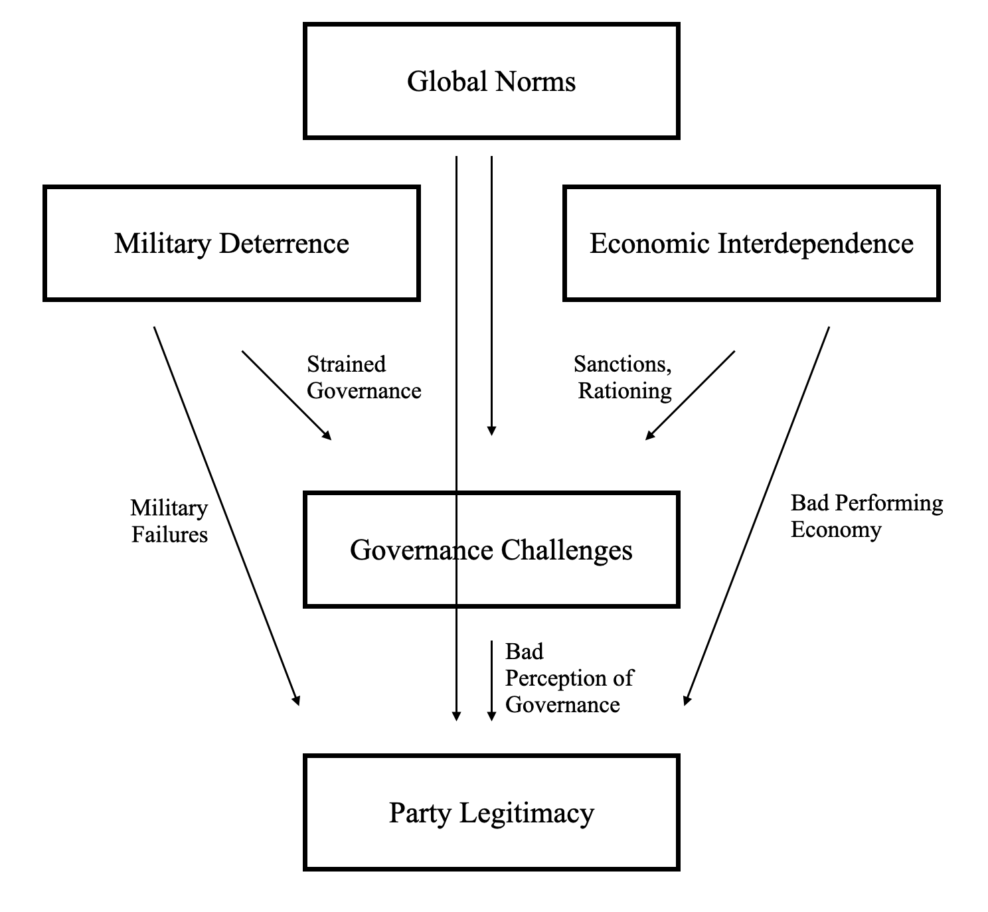The following diagram provides a visualization of my theoretical framework for understanding the deterrents toward a Chinese invasive war of Taiwan:

Figure 2. A Deterrence Framework for Understanding China’s Restraint in a Taiwan Invasion

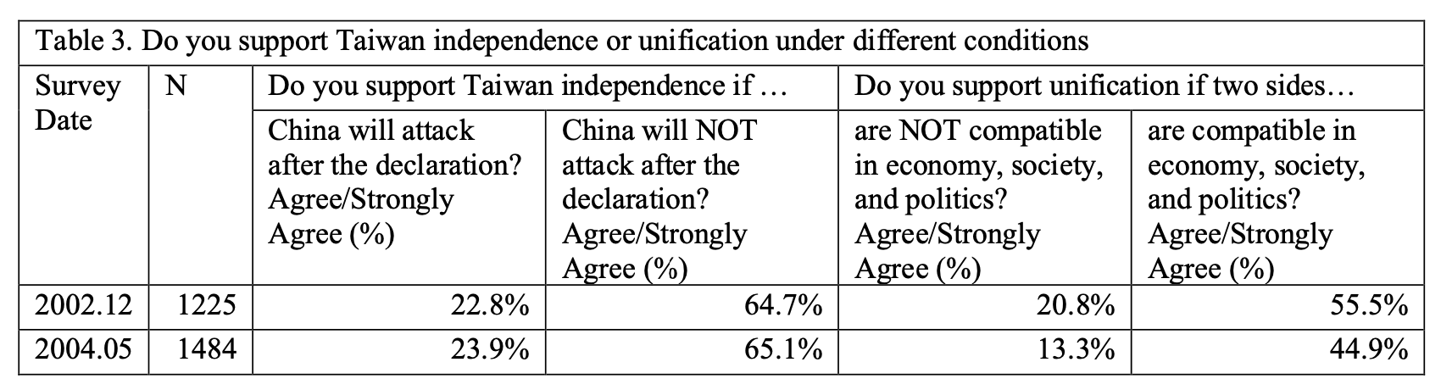Figure 3 presents an example of a conditional preference framework in unification-independence stances of a Taiwanese individual.

Figure 3. Support for Taiwanese Independence/Unification under conditions

### **Research Methodology**

**Deterrence Mechanisms Analysis**

To investigate the effectiveness of governance-legitimacy challenges in deterring China’s military invasion of Taiwan. I will rely on domestic public opinion surveys and Natural Language Processing (NLP) of online discourses.

1. **Survey and Public Opinion Data:** This study will analyze available Chinese public opinion datasets to assess how military setbacks, or economic downturns influence public support for the CCP and its Taiwan policy. For instance, survey data can be used to test whether economic hardships correlate with lower public support for adventurous wars.

Given the limited availability of publicly accessible and high-quality data on politically sensitive issues, I plan to supplement existing datasets by collecting original public opinion data. The specific survey questions, wording, and platform will be developed in the later stages of this research. Several large-scale public opinion datasets from previous years provide useful insights into Chinese societal attitudes. The Chinese General Social Survey (CGSS)[38] systematically tracks changes in social structure and quality of life in both urban and rural China, while the China Family Panel Studies (CFPS)[39] offers extensive data on economic and non-economic aspects of well-being. However, a key limitation of both CGSS and CFPS is their heavy emphasis on economic indicators, making them less effective for capturing political attitudes toward Taiwan or regime legitimacy concerns.

Also, because of the increasing difficulty of conducting politically sensitive surveys in China, this study may also utilize the World Values Survey (WVS), which includes more direct measures of political participation and attitudes toward governance and survey responses from China in the previous years. The WVS has been particularly useful in past studies on perceptions of authoritarian political behavior and was employed in my earlier research on Chinese civil compliance during COVID-19.

1. **Natural Language Processing (NLP):** Using NLP techniques, I plan to conduct a sentiment analysis of Chinese-language discourse about Taiwan on social media (e.g. Weibo and Rednote) and official statements. By collecting posts and comments overtime, especially focusing on the before and after of key events (such as the 2022 economic recession or 2024 stock crashes), I can detect changes in public opinion. Machine learning classifiers will identify changes in tone - for example, an increase in negative or wary sentiment when a crisis entails potential costs of conflict; a prime example would be the Pelosi visit in 2022, many Chinese netizens responded not with support but with sarcasm and concerns about the costs of war[40]. I will examine such sentiment shifts by comparing text data before and after events (e.g. using difference in difference approach on sentiment scores).

**Taiwanese Public Opinion Analysis**

To understand evolving attitudes in Taiwan regarding independence and identity, I will utilize long-running survey data and incorporate process tracing of key events.

1. Taiwan National Security Studies (TNSS)[41]: I will utilize data from TNSS - a Duke University supported academic survey conducted periodically since 2002 until 2024 to track trends in national identity and preferences on Taiwan’s future status. This dataset, with 1500 respondents per wave, captures how Taiwanese identify themselves (as Taiwanese v. Chinese or both) and their stances on independence v. unification under various conditions (Chinese system compatibility, Chinese military threat, U.S. security guarantee, and party identification etc.). Using TNSS data, I can perform longitudinal analyses to track public opinion change over time. Logistic regression models, at the same time, can test which factors best predict pro-independence sentiment, including demographic variables (age, education), party affiliation, and perceptions of China. A key value of the TNSS dataset is its inclusion of conditional scenario questions. I will follow Niou’s (2004) and Wang et al.’s (2025) methodology with more conditioning variables and newer data to see if the conditional preferences hold today.

Figure 4. Example Question from TNSS that measures the effect social/government compatibility and “One Country, Two Systems” on attitudes toward unification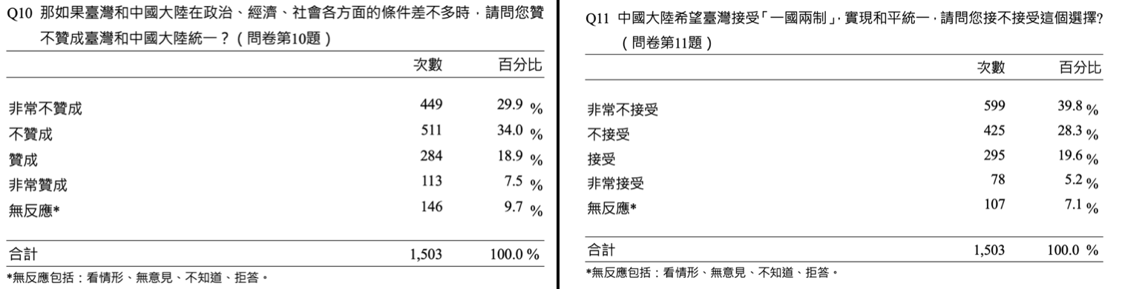

1. **Process Tracing of Key Events:** To complement the quantitative analysis, this study will employ process tracing of pivotal events in cross-strait relations and their impact on public opinion. By analyzing key events such as Hong Kong’s 2019–2020 crackdown, high-level U.S. visits (e.g., Pelosi’s 2022 trip), Chinese military escalations, and major U.S. arms sales, this research will explore whether and how such events prompt Taiwanese sentiment toward independence.

For instance, Hong Kong’s National Security Law led to a surge in Taiwanese pro-independence sentiment, as evidenced by its role in Taiwan’s 2020 presidential election[42]. Similarly, the study will assess whether U.S. diplomatic moves or Chinese military threats correspond to public opinion by examining news sources, official government statements (e.g., Taiwan’s Mainland Affairs Council reports, CCP Taiwan Affairs Office statements), and polling data (such as Taiwan’s TV station polls) from immediately before and after these events.

This qualitative analysis will help distinguish causation from mere correlation by linking statistical trends to real-world events. For example, if survey data reveal a significant decline in support for unification post-2020, process tracing may connect this shift to China’s imposition of the National Security Law in Hong Kong. By combining quantitative survey analysis with case studies, this approach ensures a more comprehensive and empirically grounded understanding of how key geopolitical events shape Taiwanese public attitudes toward cross-strait relations.

### **Analytical Techniques:**

**Quantitative Analysis:** I will apply advanced statistical methods to the survey and textual data. For survey data (both Chinese and Taiwanese), regression analysis will be used to test relationships between independent variables (e.g. economic perceptions, threat level, demographics) and dependent variables (support for Taiwan policy or preference for independence). Logistic regression is suitable for binary outcomes (such as favor independence vs. not), while multinomial logistic models can handle multi-category outcomes (e.g. unification vs. status quo vs. independence). I will also employ difference-in-differences (DID) where possible. On the NLP side, I will use sentiment scoring (e.g. via a supervised machine learning classifier) to quantify the positivity/negativity of Chinese social media discussions about Taiwan. Statistical tests (t-tests) can then determine if sentiment scores differ significantly before and after key events. All quantitative analyses will be conducted with appropriate controls and robustness checks (p-values, R²) to ensure validity.

**Qualitative Analysis:** To complement the numbers, I will perform qualitative research that contextualizes the causal mechanisms behind the trends. I will carry out case study comparisons by selecting a few critical cases on each side of the Strait to examine in detail. On the Chinese side, as noted, cases like the aftermath of the 1979 Vietnam war or the public reaction to the 2022 Pelosi visit will be studied through official documents, media reports, and social media posts. On the Taiwanese side, I might qualitatively examine periods of heightened tension (like the 1995–96 missile crisis or the 2014 Sunflower Movement) to see how public opinion and identity narratives responded. Each case study will involve reviewing leadership speeches, state media framing, and if available, internal CCP or Taiwanese government documents, to assess how deterrence mechanisms (like the fear of failure or international pressure) were communicated and perceived.

I will use thematic content analysis on these texts – coding for themes such as “emphasizing economic stability,” “nationalist rhetoric,” “appeals to security,” or “calls for patience.” For example, analyzing China's Taiwan Affairs Office and Ministry of National Defense’s speeches over time can reveal changing tones about Taiwan (harsh rhetoric vs. periods of restraints), which I can correlate with my quantitative findings on Chinese public sentiment. Similarly, examining Taiwanese presidential addresses or Mainland Affairs Council statements might show how references to independence or the status quo evolve alongside public opinion trends. Qualitative insights from these sources will help explain why certain patterns are observed in the data.

1. Niou, Emerson M. S. 2004. “Understanding Taiwan Independence and Its Policy Implications.” *Asian Survey* 44 (4): 555–67. <https://doi.org/10.1525/as.2004.44.4.555>
2. Fearon, James D. “Rationalist Explanations for War.” *International Organization* 49, no. 3 (1995): 379–414. http://www.jstor.org/stable/2706903.
3. Sacks, David. 2022. “Why China Would Struggle to Invade Taiwan.” *Council on Foreign Relations*, October 13, 2022. https://www.cfr.org/article/why-china-would-struggle-invade-taiwan.
4. Walker D. Mills, “Deterring the Dragon: Returning U.S. Forces to Taiwan,” *Military Review*, September-October 2020, https://www.armyupress.army.mil/Journals/Military-Review/English-Edition-Archives/September-October-2020/Mills-Deterring-Dragon/.
5. McKinney, Jared M., and Peter Harris. 2021. “Broken Nest: Deterring China from Invading Taiwan.” *Parameters* 51 (4): 23–36. https://doi.org/10.55540/0031-1723.3089.
6. Wuthnow, Joel. 2020. “System Overload: Can China’s Military Be Distracted in a War over Taiwan?” *Institute for National Strategic Studies*, June 2020. https://inss.ndu.edu/Media/News/Article/2232448/system-overload-can-chinas-military-be-distracted-in-a-war-over-taiwan/.
7. Simmons, Beth A. “International Law and State Behavior: Commitment and Compliance in International Monetary Affairs.” *American Political Science Review* 94, no. 4 (2000): 819–35. https://doi.org/10.2307/2586210.
8. Cunningham, Fiona S., and M. Taylor Fravel. “Assuring Assured Retaliation: China’s Nuclear Posture and U.S.-China Strategic Stability.” *International Security* 40, no. 2 (2015): 7–50. http://www.jstor.org/stable/43828294.
9. Collins, Gabriel B., and Andrew S. Erickson. 2021. “U.S.-China Competition Enters the Decade of Maximum Danger: Policy Ideas to Avoid Losing the 2020s.” Houston, TX: Rice University’s Baker Institute for Public Policy.
10. Organski, A. F. K. 1959. “World Politics. By A. F. K. Organski. (New York: Alfred A. Knopf. 1958. Pp. Xii, 461.).” *American Political Science Review* 53 (2): 587–587. <https://doi.org/10.1017/S000305540023325X>.
11. Kim, Woosang, and Scott Gates. 2015. “Power Transition Theory and the Rise of China.” *International Area Studies Review* 18 (3): 219–26. <https://doi.org/10.1177/2233865915598545>.
12. Oneal, John R., Frances H. Oneal, Zeev Maoz, and Bruce Russett. “The Liberal Peace: Interdependence, Democracy, and International Conflict, 1950-85.” *Journal of Peace Research* 33, no. 1 (1996): 11–28. http://www.jstor.org/stable/425131.
13. Whitten, Gregory, Xiaoyi Dai, Simon Fan, and Yu Pang. 2020. “Do Political Relations Affect International Trade? Evidence from China’s Twelve Trading Partners.” *Journal of Shipping and Trade* 5 (1): 21. <https://doi.org/10.1186/s41072-020-00076-w>.
14. Lin, Justin Yifu, and Yan Wang. 2012. “China’s Integration With The World: Development As A Process Of Learning And Industrial Upgrading.” *China Economic Policy Review* 01 (01): 1250001. <https://doi.org/10.1142/S179396901250001X>.
15. Kholodilin, Konstantin A., and Aleksei Netšunajev. 2019. “Crimea and Punishment: The Impact of Sanctions on Russian Economy and Economies of the Euro Area.” *Baltic Journal of Economics* 19 (1): 39–51. <https://doi.org/10.1080/1406099X.2018.1547566>.
16. Nelson, Rebecca M. 2025. “The Economic Impact of Russia Sanctions.” *Congressional Research Service*, February 20, 2025. https://crsreports.congress.gov/product/pdf/IF/IF12092.
17. Fajgelbaum, Pablo, and Amit Khandelwal. 2021. “The Economic Impacts of the US-China Trade War.” *NBER Working Paper No. 29315*. National Bureau of Economic Research. https://www.nber.org/papers/w29315.
18. Drezner, Daniel W., Henry Farrell, and Abraham L. Newman, eds. 2021. *The Uses and Abuses of Weaponized Interdependence*. Erscheinungsort nicht ermittelbar: Nomos Verlagsgesellschaft mbH & Co. KG. <https://doi.org/10.5771/9780815738381>.
19. Kastner, Scott L. 2006. “Does Economic Integration Across the Taiwan Strait Make Military Conflict Less Likely?” *Journal of East Asian Studies* 6 (3): 319–46. <https://doi.org/10.1017/S1598240800004598>.
20. McKinney, Jared, and Peter Harris. 2024. *Deterrence Gap: Avoiding War in the Taiwan Strait*. National Defense University Press.
21. Pearson, Margaret, Meg Rithmire, and Kellee S. Tsai. 2021. “Party-State Capitalism in China.” *Current History* 120 (827): 207–13. <https://doi.org/10.1525/curh.2021.120.827.207>.
22. Kulshrestha, Sujay. 2010. “Wartime Rationing During World War II and the Effect of Public Opinion in Great Britain and Austria.” *Inquiries Journal* 2 (12). <http://www.inquiriesjournal.com/articles/339/wartime-rationing-during-world-war-ii-and-the-effect-of-public-opinion-in-great-britain-and-austria>.
23. Zhang, Yinxian. 2022. “Passive Political Legitimacy: How the Chinese Online Sphere Went from Challenging to Supporting the State within the Past Decade.” *The China Journal* 88 (July):29–54. <https://doi.org/10.1086/719953>.
24. Keck, Margaret E., and Kathryn Sikkink. 1998. “Transnational Advocacy Networks in International Politics: Introduction.” In *Activists beyond Borders: Advocacy Networks in International Politics*, 1–38. Cornell University Press. http://www.jstor.org/stable/10.7591/j.ctt5hh13f.4.
25. Hurd, Ian. 1999. “Legitimacy and Authority in International Politics.” *International Organization* 53, no. 2: 379–408. http://www.jstor.org/stable/2601393.
26. Tseng, Pin-Tsang. 2018. “The Wartime Regime and the Development of Public Diet in Taiwan (1947–1950s).” *Journal of Current Chinese Affairs* 47 (2): 113–36. <https://doi.org/10.1177/186810261804700205>.
27. McBeath, Gerald A. 2018. *Wealth and Freedom*. 0 ed. Routledge. <https://doi.org/10.4324/9780429432187>.
28. Adorjan, Michael, Paul Vinod Khiatani, and Wing Hong Chui. 2021. “The Rise and Ongoing Legacy of Localism as Collective Identity in Hong Kong: ReSinicisation Anxieties and Punishment of Political Dissent in the Post-Colonial Era.” *Punishment & Society* 23 (5): 650–74. <https://doi.org/10.1177/14624745211040308>.
29. Gerschewski, Johannes. 2013. “The Three Pillars of Stability: Legitimation, Repression, and Co-Optation in Autocratic Regimes.” *Democratization* 20 (1): 13–38. <https://doi.org/10.1080/13510347.2013.738860>.
30. Tang, Wenfang. 2016. *Populist Authoritarianism: Chinese Political Culture and Regime Sustainability*. Oxford University Press. <https://doi.org/10.1093/acprof:oso/9780190205782.001.0001>.
31. Zweig, David. 2024. “China’s Political Economy.” In *Politics in China*, edited by William A. Joseph, 4th ed., 294–334. Oxford University PressNew York. <https://doi.org/10.1093/oso/9780197683200.003.0009>.
32. “Election Study Center, NCCU-Taiwan Independence vs. Unification with the Mainland(1994/12~2024/12)

    .” 2025. Accessed March 6, 2025. <https://esc.nccu.edu.tw/PageDoc/Detail?fid=7801&id=6963>.
33. Chu, Yun-han. 2004. “Taiwan’s National Identity Politics and the Prospect of Cross-Strait Relations.” *Asian Survey* 44 (4): 484–512. <https://doi.org/10.1525/as.2004.44.4.484>.
34. Sobel, Richard, William-Arthur Haynes, and Yu Zheng. 2010. “The Polls—Trends: Taiwan Public Opinion Trends, 1992–2008: Exploring Attitudes On Cross-Strait Issues.” *Public Opinion Quarterly* 74 (4): 782–813. <https://doi.org/10.1093/poq/nfq045>.
35. Wang, Austin Horng-En, Charles K S Wu, Fang-Yu Chen, and Yao-Yuan Yeh. 2025. “Undercurrent in Taiwan: Nationalism and Calculation of the Cross-Strait Relations (2002–2022).” *Public Opinion Quarterly*, February, nfae063. <https://doi.org/10.1093/poq/nfae063>.
36. Wang, T. Y. “Changing Boundaries: The Development of the Taiwan Voters’ Identity.” In *The Taiwan Voter*, edited by T. Y. Wang and Christopher H. Achen, 45–70. University of Michigan Press, 2017. http://www.jstor.org/stable/j.ctvndv9z7.6.
37. Niou, Emerson M. S. 2004. “Understanding Taiwan Independence and Its Policy Implications.” *Asian Survey* 44 (4): 555–67. <https://doi.org/10.1525/as.2004.44.4.555>.
38. National Survey Research Center (NSRC) at Renmin University of China. n.d. “Chinese General Social Survey (CGSS).” Chinese General Social Survey (CGSS). Accessed March 8, 2025. <http://cgss.ruc.edu.cn/English/Home.htm>.
39. Institute of Social Science Survey, Peking University. 2013. “China Family Panel Studies (CFPS).” Accessed March 8, 2025. <http://cgss.ruc.edu.cn/English/Home.htm>.
40. Wang, Tao. 2024. “China’s Public Wants to Make a Living, Not War.” *Foreign Policy* (blog). March 21, 2024. <https://foreignpolicy.com/2024/03/21/china-taiwan-public-opinion-war-economy-unification/>.
41. Niou, Emerson M. S. n.d. “Taiwan National Security Studies.” Accessed March 8, 2025. <https://sites.duke.edu/tnss/>.
42. Su, Xinqi, and Dene-Hern Chen. 2024. “Hong Kong Crackdown Turns Taiwan Against China Doctrine - Barron’s.” January 15, 2024. <https://www.barrons.com/articles/hong-kong-crackdown-turns-taiwan-against-china-doctrine-296f96b2>.